
RAMAIAH
INSTITUTE OF TECHNOLOGY
USN | 1 | M | S

(Autonomous Institute, Affiliated to VTU)
(Approved by AICTE, New Delhi & Govt. of Karnataka) Accredited by NBA & NAAC with ‘A’ Grade

MAKEUP EXAMINATIONS – FEBRUARY 2018

Course & Branch | : | B.E. : Common to all branches | Semester | : | I/II
Subject | : | Basic Electronics | Max. Marks | : | 100
Subject Code | : | EC101/201 | Duration | : | 3 Hrs

Instructions to the Candidates:
- Answer one full question from each unit.

 |  |  | UNIT – I
1. | a) |  | Show how ripples are eliminated at the output of a FWR with the help of neat diagram and waveforms. Also mention the equation used to find the ripple factor of a FWR with C filter. | CO1 | (08)
 | b) |  | Design a 6V reference source to operate from a 16V supply calculate the maximum load current that can be taken from the circuit. Assume low power zener diode. | CO1 | (06)
 | c) |  | With neat diagram explain how base width modulation takes place in a transistor connected in CE configuration. | CO1 | (06)
2. | a) |  | In a bridge rectifier transformer secondary voltage is 100Sin(wt), forward resistance of each diode is 25ohms and the load resistance is 950 ohms. Calculate: (i) DC output voltage (ii)ripple factor (iii)efficiency (iii)percentage regulation. | CO1 | (08)
 | b) |  | Explain how transistor connected in CB configuration works as constant current source with supporting equations. | CO1 | (06)
 | c) |  | With the help of neat circuit diagram and waveform explain how shunt clipper circuit. | CO1 | (06)
 |  |  | UNIT – II
3. | a) |  | Define ‘Biasing of transistor’. Explain with a neat circuit the operation of a  voltage divider bias with reference to Q point. | CO2 | (06)
 | b) |  | Derive the expressions for input current, output current and output voltage of a transistor connected in fixed bias configuration.if RB=470 K, Rc=2.2, Vcc=18V =100. Plot the DC loadline and mark the Q point.  =470k  =2.2k  =18V  =100 | CO2 | (08)
 | c) |  | List the ideal and typical practical characteristics of Op amp and explain any two characteristics. | CO2 | (06)
4. | a) |  | Draw the DC load line for the voltage divider biasing circuit referring figure  Also find the & Q point.  + | CO2 | (08)
 | b) |  | Show with a circuit diagram how an Op amp can be used as Subtractor. | CO2 | (06)
 | c) |  | Design an adder circuit using opamp to obtain an output voltage given by Vo=2 {0.1V₁+0.5V₂+2V₃} | CO2 | (06)
 |  |  | UNIT – III
5. | a) |  | Perform the following:  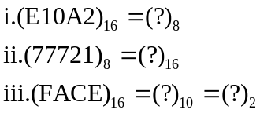 | CO3 | (06)
 | b) |  | Design and implement a full adder circuit using basic circuit. | CO3 | (06)
 | c) |  | Simplify the following:  i. 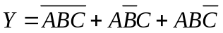 ii. 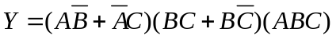 | CO3 | (08)
6. | a) |  | State and prove Demorgan’s theorem for 3 variables. | CO3 | (06)
 | b) |  | Perform the following:  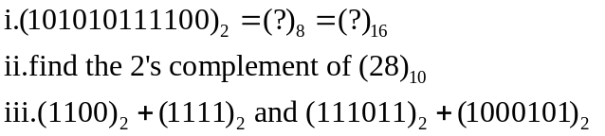 | CO3 | (06)
 | c) |  | Design and implement a full adder using two half adders. | CO3 | (08)
 |  |  | UNIT – IV
7. | a) |  | Write a block diagram of architecture of 8051microcontrollers | CO4 | (06)
 | b) |  | Discuss the details of PSW. | CO4 | (08)
 | c) |  | Design and explain clocked RS flip flop. | CO4 | (06)
8. | a) |  | Show how one bit is stored in a NAND latch. | CO4 | (04)
 | b) |  | Explain the memory organization of 8051 microcontroller. | CO4 | (06)
 | c) |  | With neat block diagram explain working of microcontrollers. Explain the features of 8051. | CO4 | (10)
 |  |  | UNIT – V
9. |  | a) | Define Amplitude modulation. With the help of necessary waveforms derive the AM wave equations. | CO5 | (10)
 |  | b) | Write short notes on:  i. Resistive transducers ii. Thermoelectric transducers. | CO5 | (10)
10. |  | a) | For an AM wave it’s found that 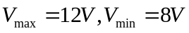  Find: i) 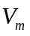ii) 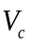 iii) % modulation index iv) Total power across 50 ohm load. | CO5 | (05)
 |  | b) | Define frequency modulation. How its different from amplitude modulation. | CO5 | (05)
 |  | c) | With a neat circuit diagram explain detection of AM signal. | CO5 | (05)
 |  | d) | Explain with neat diagram LVDT transducer. | CO5 | (05)

****************

